**Monster Puzzle Bobble**

Draft specification

Author: Ruell Magpayo [ruellm@yahoo.com](mailto:ruellm@yahoo.com)

This document will describe the things needed for the Puzzle Bobble clone project. All things described in here are subject to discussion with the members involved.

**Screens**

The anatomy of a Facebook Puzzle game app contains the following basic screens.

1. **Loading screen**
2. **Map** – the map describes the level progress of the user, it also contains information such as the user’s friends who played on specific level.

**Note: For a monster bobble puzzle game, we can have a ladder style system where a user climbs thru the ranks of the ladder rather than a mapping system to be unique.**

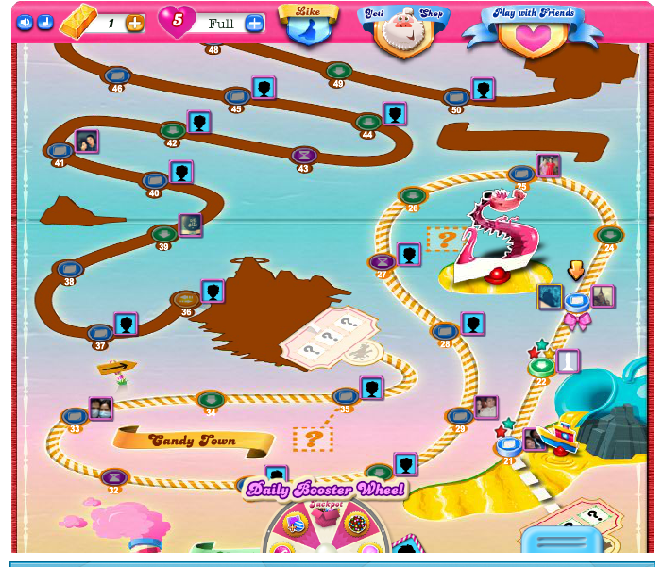

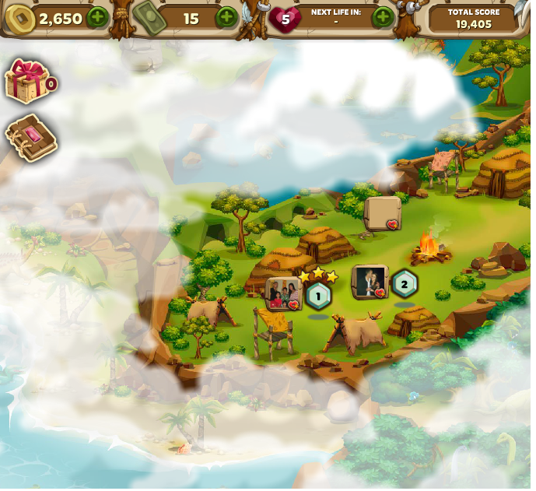

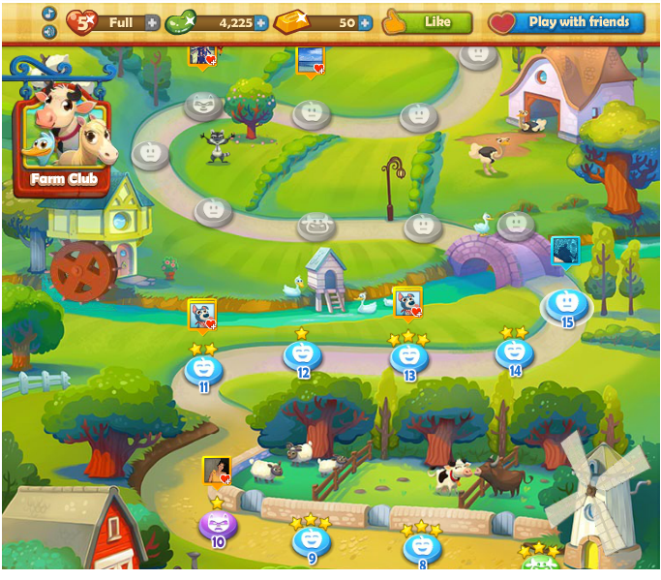

1. **Map Level Info (window)** – contains the following informations;
   1. Leaderboards for the user’s friends on the side
   2. Target score and goal for the level
   3. Offered boosters to be used

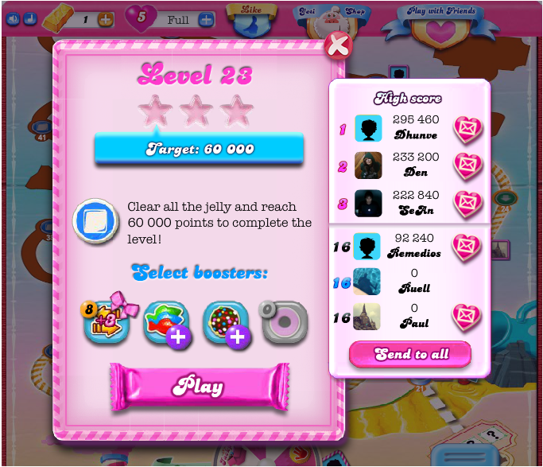

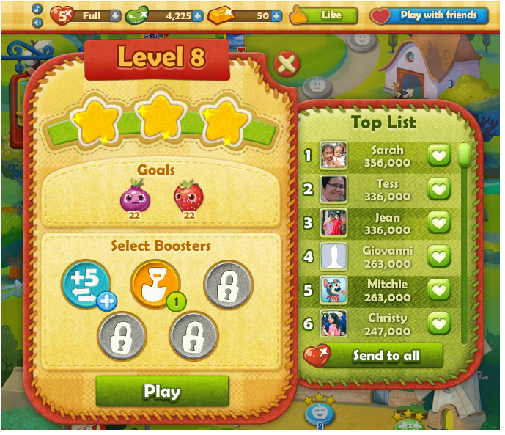

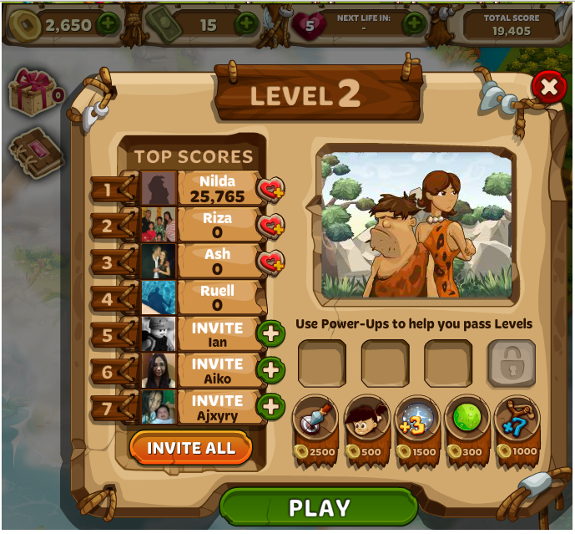

1. **In game screen** – the main game screen itself

During game screen the following elements must be present

* 1. The toolbar that is visible on all levels that shows current gold count, and current lives. The toolbar will also show the current boosters for each level and the current score.
  2. A way for user to purchase and boosters or additional bubble. See screenshots.

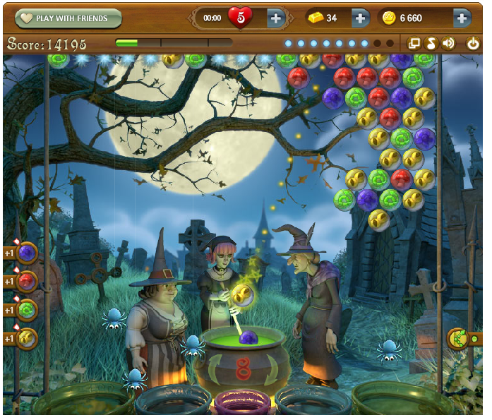

**Number of moves remaining**

**BUY Lives and Gold**

**ADD Additional Bubble of choice**

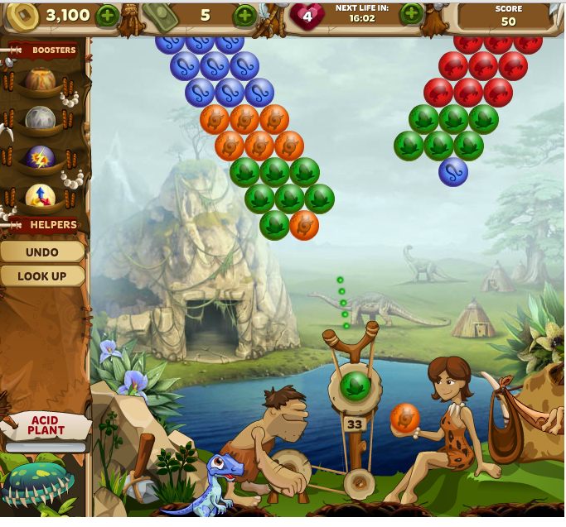

By clicking on the boosters, the boosters will be used.

We must find a way to present booster use during game play similar to this.

(BubbleAge).

1. **Level complete/failed screen**
   1. There is always a shared button on the level complete screen, scores and updates will be shared to Facebook wall.
   2. Although only candy crush has the ‘Next’ button, it is more practical to have that button after every level to allow the user to proceed to next level without going back to the map screen.

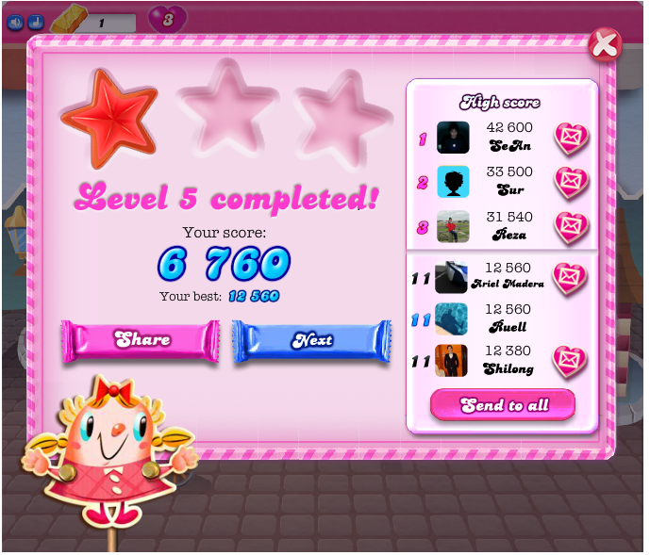

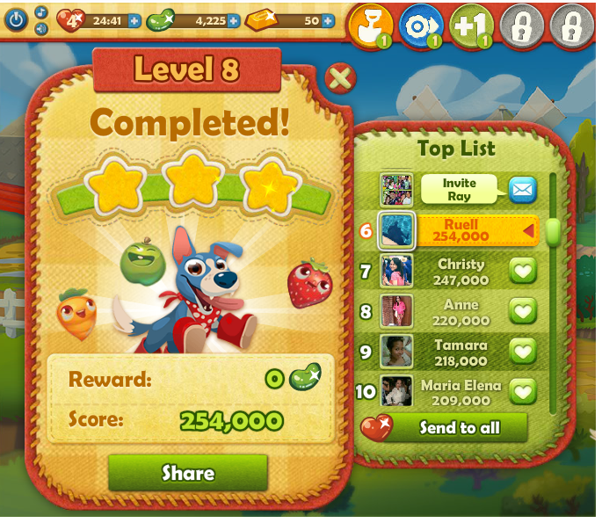

1. **Purchase booster screen** – this is the screen where the user buy booster using in-game currency Ex: Gold.

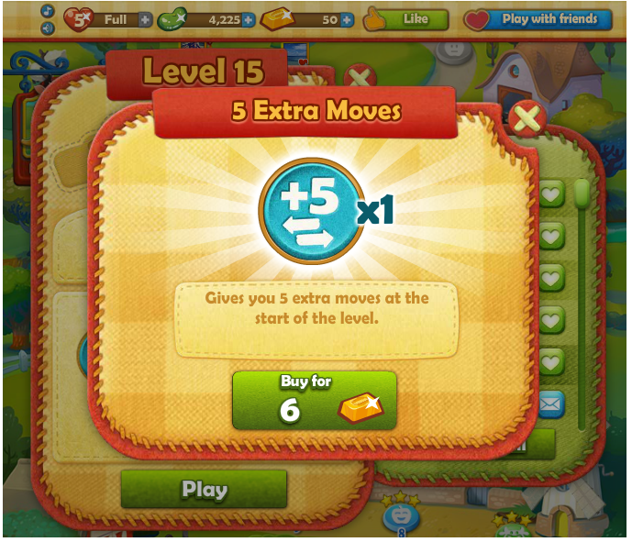

Purchase booster screen for Farm Heroes using Gold.

1. Purchase Gold screen – this is the screen where user needs to buy the Gold.

**Note: The buy Gold screen can be triggered by clicking the “+” besides the Bold icon in the toolbar which can be seen on every screen.**

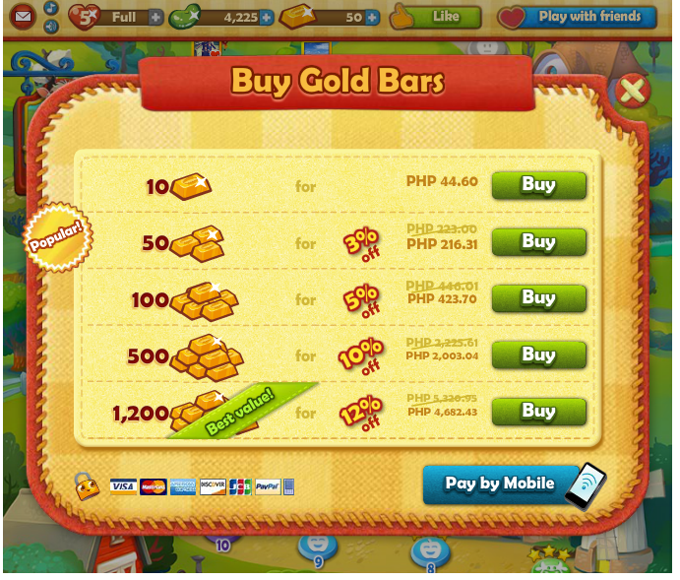

To purchase in-app items, you need to purchase in app currency such as Gold.

1. Invite friends screen (To be decided). This can be implemented as a button and not a screen similar to Titays Rosquillos Facebook game and BubbleAge. The button is displayed on top of the game.

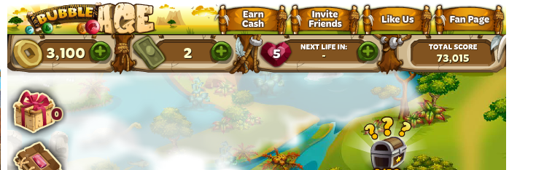

Clicking this button triggers the Facebook  
invite friends dialog and no further art needed.

**Game Play**

**Them**e

1. Monster type game similar to original Puzzle Bobble where monsters serve as the ‘plot device’ of the game.

Below are my theme suggestions;

* 1. Cute monster type theme similar to Monsters inc. movie
  2. Radioactive nuclear theme where bubbles glow.
  3. 8-bit monster type themed similar to original puzzle bubble.
  4. Dark monster type theme similar to bubble witch.
  5. HD graphics similar to Facebook Bubble Age game.

1. Animations
   1. Bobble, there will be animation when the bubble is attached similar to the original Puzzle Bobble. In Puzzle Bobble game, once the bubble is deployed, the bubble ‘shines’.
   2. Monster background animation
      1. Worry animation
      2. Cheer
      3. Defeated animation
2. Instead of a map type to show level progress. We can have a sort of Ladder system where user rise thru the ranks instead.
3. Sounds and background SFX – the game will have the upbeat feel of the original Puzzle Bobble game.

**General Play**

1. The game will have an upbeat play similar to Puzzle Bobble.
2. The game will also have a limit time for player to shoot similar to Puzzle Bobble, if the player idles for a number of seconds, the bubble will be automatically launched based on the current angle. (TBD)
3. The user will have a limited number of bubble per level. The user can add additional moves/bubble buy purchasing using in-game gold.
4. The user will be given five lives per day. The user can either buy additional lives or ask from friends.
5. Unlike most of the Facebook bubble clone, the game will follow the original style where in if the bubble reaches specific line near the gun, the game will be over.

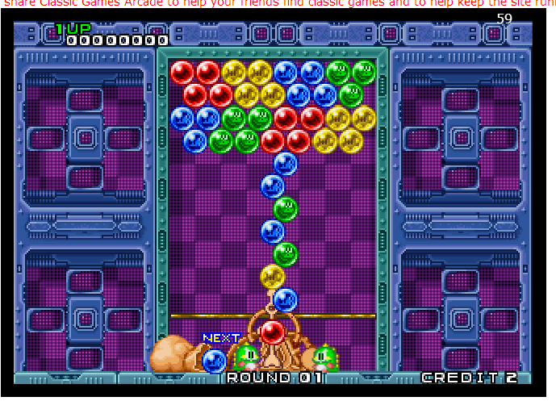

**If Bubble reaches beyond this line,   
the game/level is over.**

1. If the player made 5 shoots without making a match, a wall on top will be pushed down, this adds the challenge for the player.

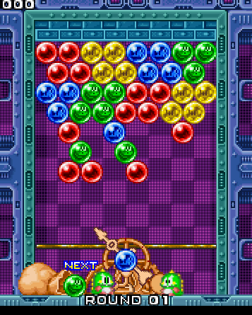

**A brick of wall was pushed down, pushing the entire**

**Bubble field near the limit line when user missed 5 shots**

**Without making a match.**

**Level objectives**

Most of the Facebook Puzzle Bobble game clone objective is to clear at least 10 ‘bank’ on top.



**Clear the Bank**

For Monster type Bobble game, the objectives will be a combination of the original game and the above. These two level objectives alone is worth around 50-100 levels.

1. Clear all the bubbles similar to Puzzle Bobble (Original).
2. Clear at least 10 bank on top.
3. Reach a minimum number of score.
4. Collect number of bubble types per level (similar to farm heroes).

**Boosters**

The following boosters will be supported for the game;

Note: Boosters are subject to change during development phase.

1. Rainbow bubble – can be paired or match to any bobble.
2. Bomb bubble – shot to any bubble and clears (or explode) surrounding bubble regardless if it matched or not.
3. Score booster bubble – increases the bubble point count when matched with paired bubble.
4. Paint booster – Paint adjust bubble the same color as the bubble it hits.

(To be added during development phase)

**In App Purchase**

User needs to buy the game currency which is Gold.   
With the in-game gold, user can purchased the following items:

1. The user can purchase additional moves/bubbles during in-game
2. Buy Boosters before level start
3. Buy lives.

**Reference**

<https://apps.facebook.com/farmheroes/>

<https://apps.facebook.com/candycrush/>

<https://apps.facebook.com/bubbleage/>

<https://apps.facebook.com/bubblewitch/>

<https://apps.facebook.com/bubble_land/>

<http://www.classicgamesarcade.com/game.php?gId=21606&fname=puzzle-bobble>